Exp 9: Create a Scrum Project in Jira.
- · Add a backlog with at least 5 items (e.g., "Create user registration page",
"Develop API for login").
- · Prioritize the backlog and create a 1-week sprint.
- · Move backlog items into the sprint and start the sprint.
- · Finally show the Screenshot of the sprint board at the start and end of the sprint.

Step 1: Create a Scrum Project
- Select the Scrum template.
- Click Use Template.
- Select Team-managed Project.
- Enter the project name, for example Bus Booking Scrum Project.
- Click Create Project.
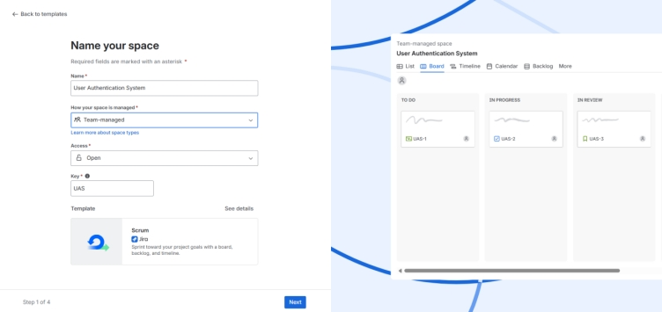

Step 3: Open the Backlog
- From the left menu, click Backlog.
- The backlog page opens.

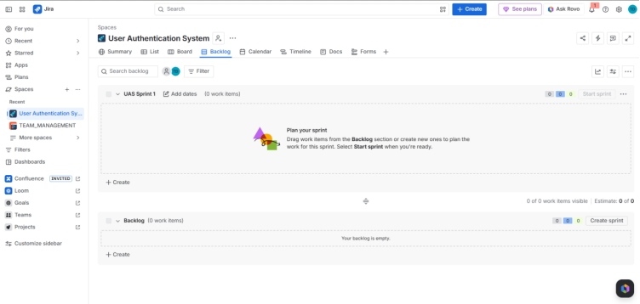
Step 3: Add Backlog Items
Click Create and add the five Story issues.

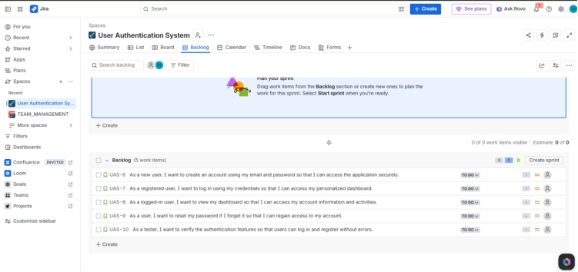
Step 4: Create a Sprint
- Click Backlog.
- Click Create Sprint.
A new sprint named Sprint 1 will appear.
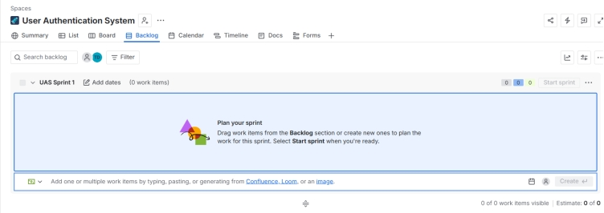

Step 5: Move Stories into Sprint
Drag all five stories from the Backlog into Sprint 1.
Your sprint should look like this:
Sprint 1
- User Registration
- User Login
- User Dashboard
- Password Reset
- Authentication Testing

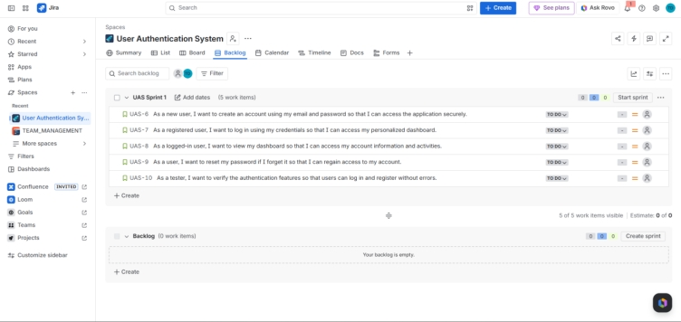

Step 6: Start the Sprint
Click Start Sprint.
Click Start.
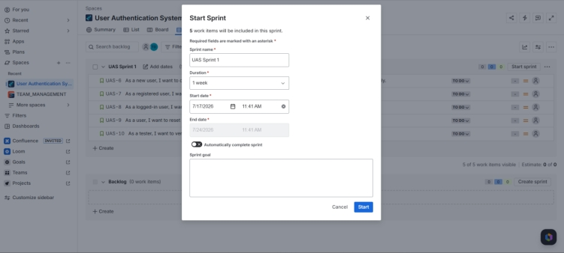
Step 7: Sprint Board at the Start
Click Board.

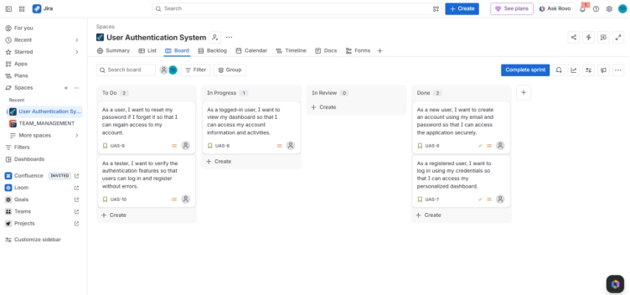
Step 8: Update Story Status
Move the stories as complete them.
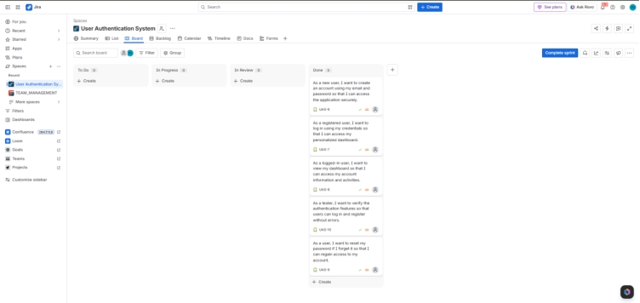

Step 9: Complete the Sprint
When all stories are finished, the board should like this

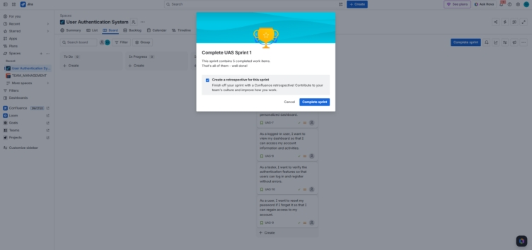
Step 10: Complete the Sprint
- Click Complete Sprint.
- Verify that all issues are in the Done column.
- Click Complete.



